|  |
| --- |
| **Experimentation (part 2)** |
| Follow the following steps and tasks. In some of them, you will be asked to take screenshots or record your time. |
| The collaborative configuration during this experiment will take place in a sequential way (workflow) where each participant will have a module to configure in a specific order according to a configuration plan defined by the product manager who will be in charge of assigning the configuration tasks to the participants.  *If you are reading this, you are playing the role of the product manager. ☺* |

The web portal model that was configured during the first part of the experiment is now decomposed into several modules as shown in the following figure:

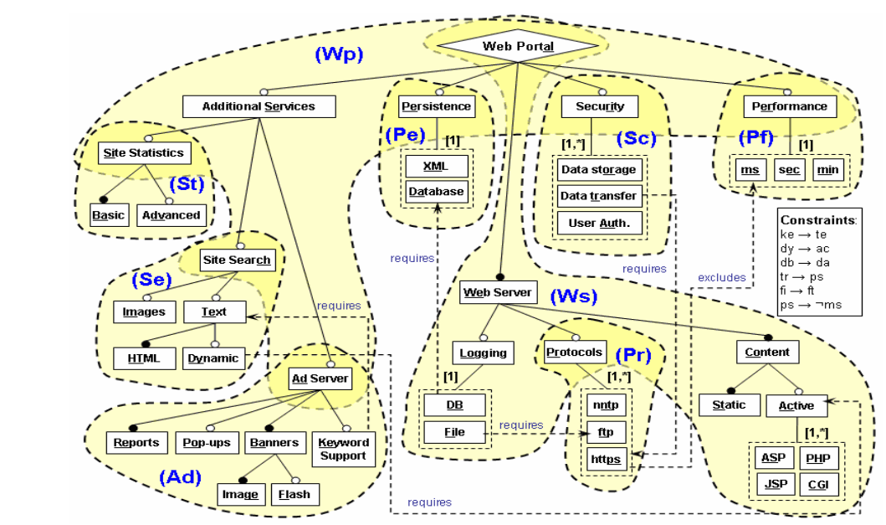

**Figure 1**: model of web portals broken down into modules.

These modules are linked according to two types of dependencies: high dependency and low dependency as illustrated by the dependencies network below.

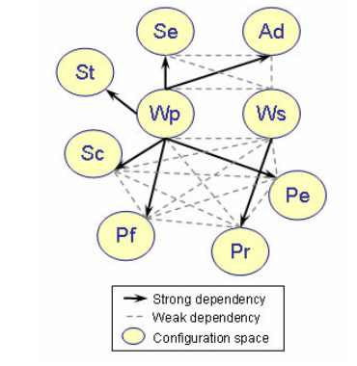

**Figure 2** : Network dependencies.

Two modules that are highly dependent on each other must be configured sequentially. That in other words, if Module B is strongly dependent on Module A, A must be configured first. As is the case, for example, between module (Wp) and module (St), here (St) can only be configured after configuring (Wp) because the "Site Search" feature which is a connecting point between (Wp) and (St) will be configured in (Wp) where it is presented as a leaf. Depending on the decision of its configuration, (St) will be configured in (Wp). The same applies to all other highly dependent modules.

For low dependency modules, there is at least one "Exclude" or "Require" constraint between the characteristics that make up these modules. These modules can be configured sequentially or simultaneously. In the case of simultaneous configuration, the participants in charge of configuring these two modules are invited to negotiate possible alternatives in case of conflict.

According to the model decomposition (Figure 1) and the dependency web (Figure 2), the configuration will proceed according to the valid plan presented in Figure 3: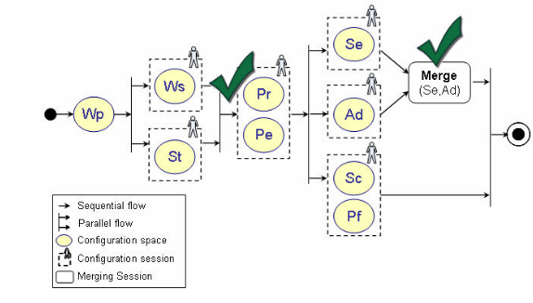

**Figure 3**: Modules configuration workflow.

* **Task 1 (Assign Configuration Tasks)**

**Current time (put the time when you are ready to start this task):** HH: MM

1. Given the decomposition principle explained above, place the participants on the map shown in Figure 3, i.e., assign each participant a module to configure. This is done as follows:



**P..**

**P..**

**P..**

**P..**

**P..**

**P..**

**P1**

1. Communicate the configuration workflow to all participants with the names next to the modules that they will configure.

**Final time (record your current time after finishing this task):** HH: MM

**Task 2 (Resolve conflicts according to the configuration workflow)**

**Current time (put the time when you are ready to start this task):** HH: MM

1. Check the choices of the participants and identify the conflicts according to the workflow.
2. Communicate to all participants the outcome of the conflict resolution process related to his or her choices (use the table below).

|  |  |  |  |  |
| --- | --- | --- | --- | --- |
| Participant | Configured Module | Respected choices | Non-Respected choices | Explication |
| Pi |  |  |  |  |

1. Communicate to all the participant the final configuration.

**Final time (record your current time after finishing this task):** HH: MM